6.66: Let x be the distance past P.
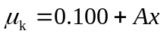
when 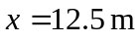, 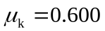
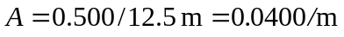

(a)
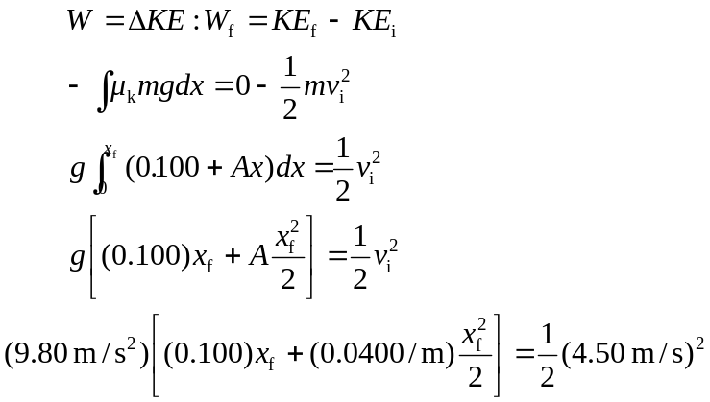
Solve for 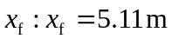
(b)
(c) 